Name: Period:
Newton’s Gravity

1. The centers of two 15 kilogram spheres are separated by 3.00 meters. The magnitude of the
gravitational force between the two spheres is approximately
(1) 1.11 x 10⁻¹⁰N (3) 5.00 x 10⁻⁹N
(2) 1.67 - 10⁻⁹N (4) 3.34. 10⁻⁹N

2. Gravitational force F exists between point objects A and B separated by distance R. If the mass of A is doubled and distance R is tripled, what is the new gravitational force between A and R?
(1) 2F/9 (3) 3F/2
(2) 2F/3 (4) 9F/2

3. The radius of Mars is approximately one-half the radius of Earth, and the mass of Mars is approximately one-tenth the mass of Earth. Compared to the acceleration due to gravity on the surface of Earth, the acceleration due to gravity on the surface of Mars is
(1) smaller
(2) larger
(3) the seme

4. What is the magnitude of the gravitational force between two 5.0-kilogram masses separated by a distance of 50 meters?
(1) 5.0 x 10⁰ N (3) 6.7 x 10⁻¹¹ N
(2) 3.3 x 10-¹⁰N (4) 1.3 x 10⁻¹¹N

5. The gravitational force of attraction between two objects would be increased by
(1) doubling the distance between the objects, only
(2) doubling the mass of both objects, only
{3) doubling the mass of both objects and doubling the distance between the objects
(4) doubling the mass of one object and doubling the distance between the objects

6. If the mass of one of two objects is increased, the force of attraction between them will
(1) decrease
(2) increase
(3) remain the same

7. As the mass of a body increases, its gravitational force of attraction on the Earth
(1) decreases
(2) increases
(3) remains the some

8. The magnitude of the gravitational force between two objects is 20 Newtons. If the mass of each object ware doubled the magnitude of the gravitational force between the objects would be
(1) 10N (3) 80N
(2)20 N (4) 50N

9. Base your answer to the following question on the information and diagram below

Spacecraft S is traveling from planet P₁ toward planet P₂. At the position shown, the magnitude of the gravitational force of planet P₁ on the spacecraft is equal to the magnitude of the gravitational force of planet P₂ on the spacecraft.
P₁
P₂
S
Distance X Distance Y
(not drawn to scale)

If distance X is greater than distance Y, then the mass of P₁ must be
(1) less than the mass of P₂
(2) greater than the mass of P₂
(3) equal to the mass of P₂

10. If the Earth were twice as massive as it is now, then the gravitational force between it and the Sun would be
(1) the same
(2) half as great
(3) twice as great
(4) four times as great

11. Compared to the mass of an object at the surface of the Earth, the mass of the object a distance of two Earth radii from the center of the Earth is
(1) the same
(2) one-half as great
(3) twice as great
(4) one-fourth as great

12. A satellite weighs 200 newtons on the surface of Earth. What is its weight at a distance of one Earth radius above the surface of Earth?
(1) 50 N
(2) 400 N
(3) 100 N
(4) 800 N

13. When a Satellite is a distance R from the center of Earth. The force due to gravity on the satellite is F.
What is the force due to gravity on the satellite when its distance from the center of Earth is 3R?
(1) 9F
(2) F/9
(3) F/3
(4) F

14. Which graph best represents the relationship between the mass (m) of a satellite launched from Earth and the satellite's distance (r) away from Earth?
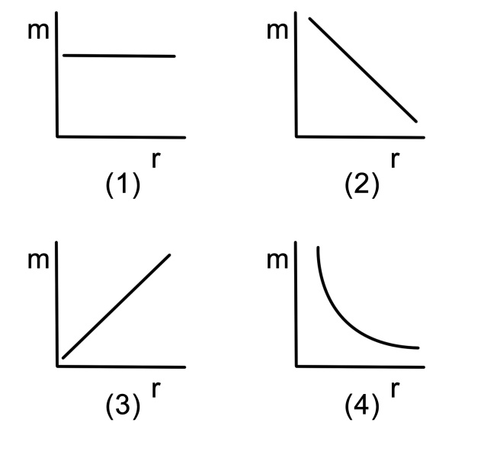
15. As the distance between two objects increases, the gravitational force of attraction between them will
(1) decrease
(2) increase
(3) remain the same

