Name: Period:
Horizontally Launched Projectiles 2 (g = 9.81m/s²)
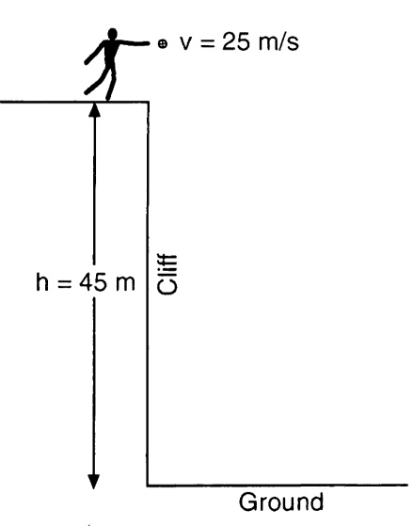
1. The diagram below shows a student throwing a baseball horizontally at 25 meters per second from a cliff 45 meters above the level ground.

Approximately how far from the base of the cliff does the ball hit the ground? (Disregard air resistance.)

2. A book is pushed with an initial horizontal velocity of 5.0 meters per second off the top of a desk. What is the initial vertical velocity of the book?

3. Justin Bieber is thrown horizontally at a speed of 20 meters per second from the top of a cliff. How long does it take the pop sensation to fall 19.6 meters to the ground?

What is the horizontal velocity of the ball just before it reaches the ground? (Disregard air resistance.)
4. A baseball player throws a ball horizontally. Which statement best describes the ball’s motion after it is thrown? (Disregard the effect of friction.)
(1) Its vertical speed remains the same, and its horizontal speed increases.
(2) Its vertical speed remains the same, and its horizontal speed remains the same.
(3) Its vertical speed increases, and its horizontal speed increases.
(4) Its vertical speed increases, and its horizontal speed remains the same.

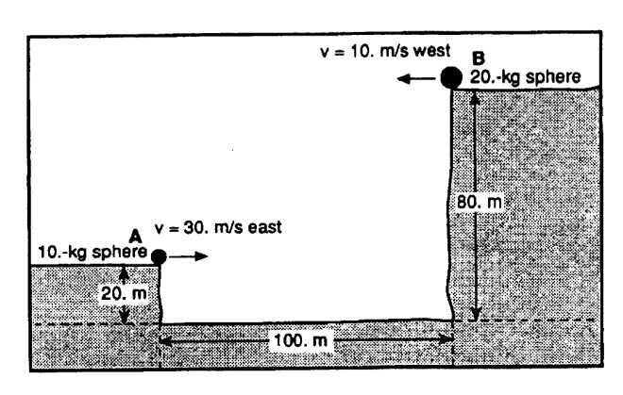
5. In the diagram below, a 10-kilogram sphere, A, is projected horizontally with a velocity of 30 meters per second due east from a height of 20 meters above level ground. At the same instant, a 20-kilogram sphere, B, is projected horizontally with a velocity of 10 meters per second due west from a height of 80 meters above level ground. (Disregard air friction.)

Initially, the spheres are separated by a horizontal distance of 100 meters. What is the horizontal separation of the spheres at the end of 1.5 seconds?

Base your answers to questions 6 and 7 on the information below.
Projectile A is launched horizontally at a speed of 20 meters per second from the top of a cliff and strikes a level surface below, 3.0 seconds later. Projectile B is launched horizontally from the same location at a speed of 30 meters per second.

6. Approximately how high is the cliff?

7. The time it takes projectile B to reach the level surface is

12. Base your answer to the following question on the diagram below which shows a ball projected horizontally with an initial velocity of 20 meters per second east, off a cliff 100 meters high. (Disregard air resistance.)
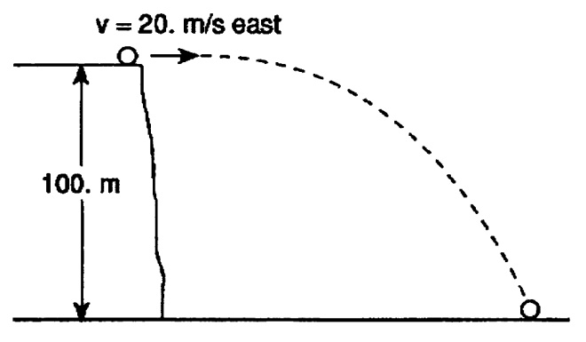

How many seconds does the ball take to reach the ground?

Base your answers to questions 9 through 11 on the information below.
A ball is projected vertically upward from the surface of the Earth with an initial speed of 49 meters per second. The ball reaches its maximum height in 5.0 seconds. (Disregard air resistance.)

9. What is the total displacement of the ball from the time it is thrown until it returns to the point from which it was thrown?

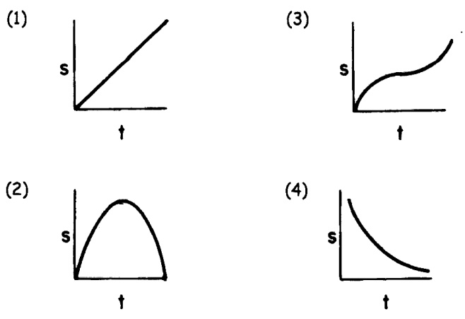
10. Which graph best represents the relationship between displacement (s) and time for the motion of the ball?

11. Which graph best represents the relationship between velocity and time for the motion of the ball?
