Name: Period:
Projectiles at an Angle 1

Base your answers to questions 1 and 2 on the information below.
An outfielder throws a baseball to the first baseman at a speed of 19.6 meters per second and an angle of 30° above the horizontal.
1. Which pair represents the initial horizontal velocity (v_{x}) and initial vertical velocity (v_{y}) of the baseball?
(1) v_{x} = 17.0 m/s, v_{y} 9.80 m/s
(2) v_{x} = 9.80 m/s, v_{y} = 17.0 m/s
(3) v_{x} 19.4 m/s, v_{y} = 5.90 m/s
(4) v_{x} = 19.6 m/s. v_{y} = 19.6 m/s

2. If the ball is caught at the same height from which it was thrown, calculate the amount of time the ball was in the air.

Base your answers to questions 3 and 4 on the information and diagram below.
A golf ball leaves a golf club with an initial velocity of 40.0 meters per second at an angle of 40° with the horizontal.
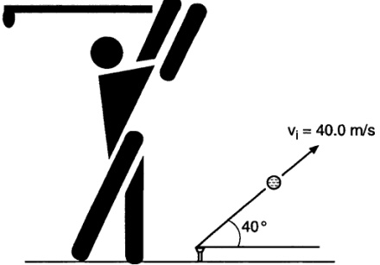

3. What is the vertical component of the golf ball’s initial velocity?

4. What is the total horizontal distance traveled by the golf ball during the first 2.50 seconds of its flight?

5. A ball is thrown at an angle of 38° to the horizontal. What happens to the magnitude of the ball’s vertical acceleration during the total time interval that the ball is in the air?
(1) It decreases, then increases.
(2) It decreases, then remains the same.
(3) It increases, then decreases.
(4) It remains the same.

Base your answers to questions 6 through 8 on the information and diagram below.
A cannon elevated at an angle of 35° to the horizontal fires a cannonball, which travels the path shown in the diagram below. (Disregard air resistance and assume the ball lands at the same height above the ground from which it was launched.)
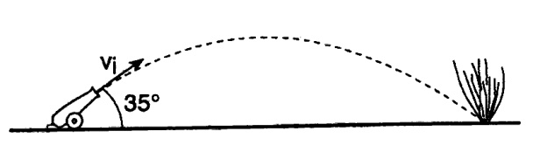

6. If the ball lands 7.0 x 10² meters from the cannon 10 seconds after it was fired, what is the horizontal component of its initial velocity?

7. If the ball’s time of flight is 10 seconds, what is the vertical component of its initial velocity?

8. If the angle of elevation of the cannon is decreased from 35° to 30°, the vertical component of the ball’s initial velocity will
(1) decrease and its horizontal component will decrease.
(2) decrease and its horizontal component will increase.
(3) increase and its horizontal component will decrease.
(4) increase and its horizontal component will increase.

