Name: Period:
Projectiles at an Angle 2

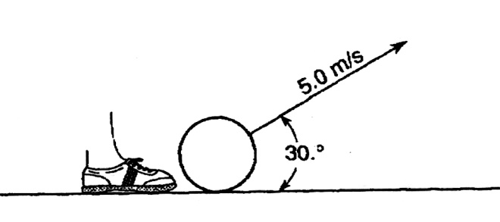
Base your answers to questions 1 through 3 on the diagram below which represents a ball being kicked by a foot and rising at an angle of 30° from the horizontal. The ball has an initial velocity of 5.0 meters per second. (Disregard friction.)

1. What is the magnitude of the horizontal component of the ball’s initial velocity?

2. As the ball rises, the vertical component of its velocity
(1) decreases (2) increases (3) remains the some

3. If the angle between the horizontal and the direction of the 5.0-meters-per-second velocity decreases from 30° to 20°, the horizontal distance the ball travels will
(1) decrease (2) increase (3) remain the same

4. A toy projectile is fired from the ground vertically upward with an initial velocity of +29 meters per second. The projectile arrives at its maximum altitude in 3.0 seconds.
(Ignore air resistance.) What is the maximum height that the projectile reaches?

5. A projectile is fired from a gun near the surface of Earth. The initial velocity of the projectile has a vertical component of 98 meters per second and a horizontal component of 49 meters per second. How long will it take the projectile to reach the highest point in its path?

Base your answers to questions 6 and 7 on the information and diagram below.
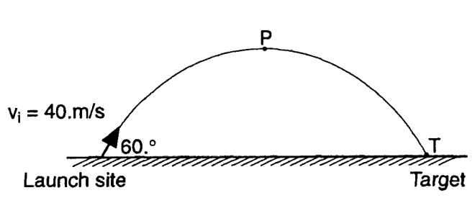
A projectile is launched at an angle of 60° above the horizontal at an initial speed of 40 meters per second, as shown in the diagram below. The projectile reaches its highest altitude at point P and strikes a target at point T (Disregard air resistance.)

6. Which graph best represents the horizontal speed of the projectile as a function of time? (Disregard air resistance.)
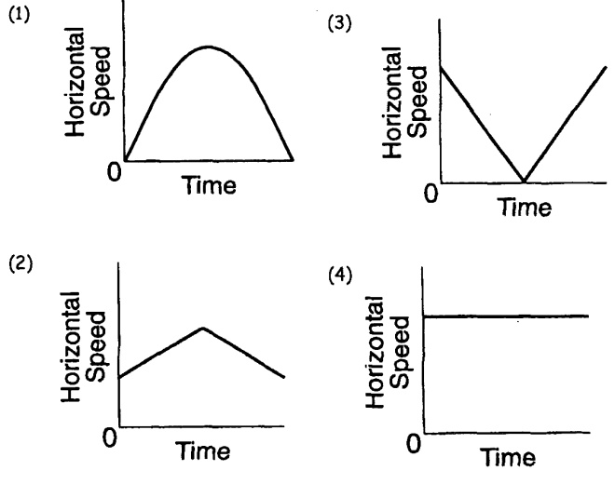

7. What is the magnitude of the vertical component of the projectiles initial speed?

8. The diagram below shows a golf ball being struck by a club. The ball leaves the club with a speed of 40 meters per second at an angle of 60° with the horizontal.
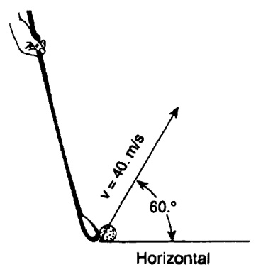
If the ball strikes the ground 7.1 seconds later, how far from the golfer does the ball land? (Assume level ground and ignore air resistance.)

